FLUORESCENT BRIGHTENER 290
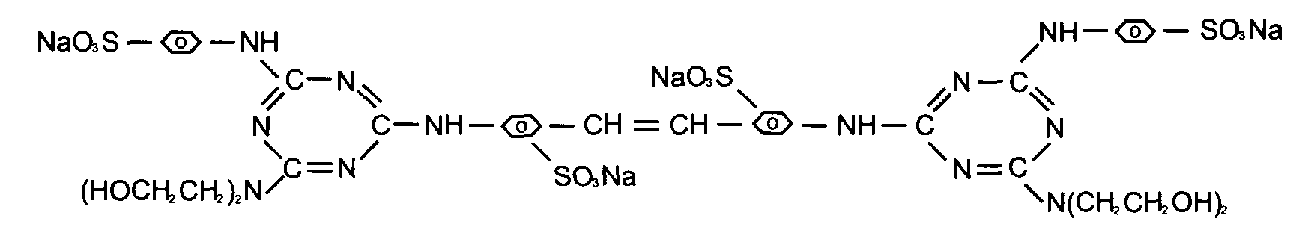
C.I.NO.: 290 Appearence: Light yellow powder
Moisture: 5%max Insoluble in water : 0.5%max
Dyeing degree: 0.4%min
Fluorescent whitening strength: 100% (Compare to the standard )
Finess (sieved reside through 80 mesh ) : 10%max
Uses: Mainly used to whiten cotton fabrics, capron fabrics and pulp, and
also used to increase brightness of lighcolored fabrics.
Packing: Iron drum lined with plastic bag,net weight 25kg per drums.

