FLUORESCENT BRIGHTENER 31
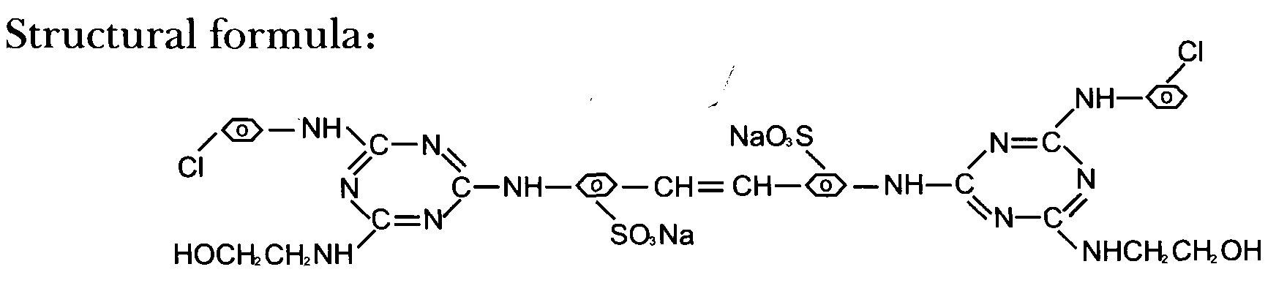
C.I.NO.: 31
Appearence: Light yellow homogeneous powder
Moisture: 5%max
Insoluble in water: 0.5%max
Dying degree: 0.4%min
Fluorescent whitening strenght: 100% (compared to standard )
Finess (sieved residue through 80 mesh) : 10%max
Uses: Mainly used for brightening of washing powder, soap paper and
artificial cotton^ nylon^ silk^ wool, etc.
Packing: Iron drum lined with plastic bag 25kg per drum.

