FLUORESCENT BRIGHTENER BA
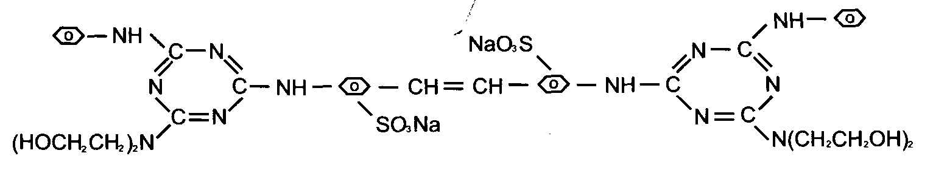
C.I.NO.: 113
Appearence: Light yellow powder
Moisture: 5%max
Dying degree: 0.4%min
Fluorescent whitening strength: 100% (Compare to the standard)
Insoluble in water: 10%max
Uses: Mainly used to whiten cotton fabrics ^ capron fabrics and pulp,
and also used to increase brightness of lighcolored fabrics. Packing: Iron drum lined with plastic bag» net weight 25kg per drums

