FLUORESCENT BRIGHTENER BC
Structural formula:
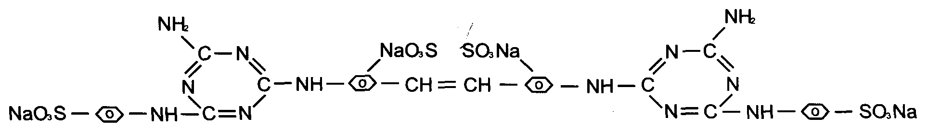
C.I.NO.: 204
Appearence: Light yellow powder
Insoluble in water: 0.5%max
Moisture: 5%max
Shade: similar to standard
Dying degree: 0.5%min
Fluorescent whitening strength: 100% (Compare to the standard)
Finess (180um) : 10%max
Uses: Mainly used to whiten cotton fibre,artificial silk and pulp.
Packing: Iron drum lined with plastic bag, net weight 25kg per drums.

