FLUORESCENT BRIGHTENER CBS-127
Structural formula:
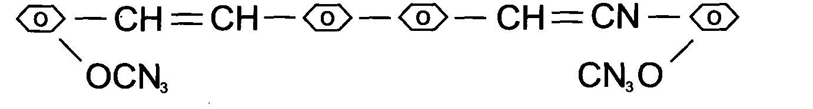
C.I.NO.: 359
Appearance: Light yellow crystal powder
Melting point: 216 -222 C
Assay: 99%min
Loss on drying: 0.5%max
Ash content: 0.1%max
Uses: Widely used in the process of plastic^ syndetergen^ artificial
fabric, also can be used in printing. Packing: 20kg paper drum lined with plastic bag.

