FLUORESCENT BRIGHTENER CXT
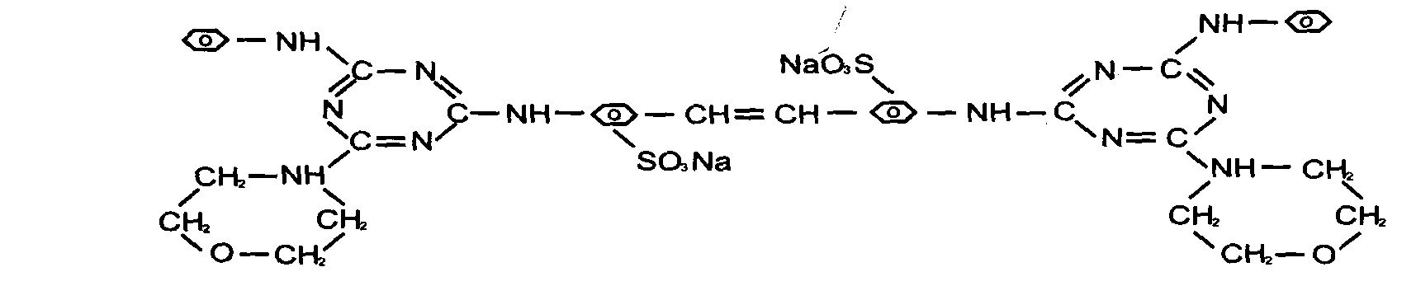
C.I.NO.: 71
Appearence: White or light yellow powder
Moisture: 0.5%max
Dying degree: 0.4%min
Fluorescent whitening strength: 100 ±3%
Finess (sieved residue through 80 mesh) : 10%max
Uses: Excellent fluorescent brightener used in syndetergent , cellulose fibre, paper for brightening and whitening. When used in washing powder soap the washedfibre will be brightened and whitened and the detersive efficiency will be improved.
Packing: 25kg paper drums

