FLUORESCENT BRIGHTENER DT
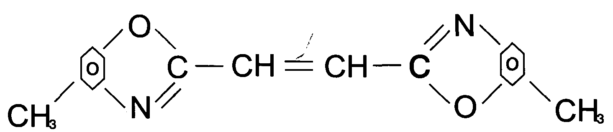
C.I.NO.: 135
Appearence: milk white suspesion
Shade: Similar to the standard sample.
Fluorescent whitening strength: 100% (Compare to the standard)
Finess (4um) : 3%max
Uses: Mainly used to whiten decron fibrics, cotton fabrics,
capron fabrics and other synthetic fibrics, and also
used to bleach fabrics. Packing: 20kg plastic drums.

