FLUORESCENT BRIGHTENER HD
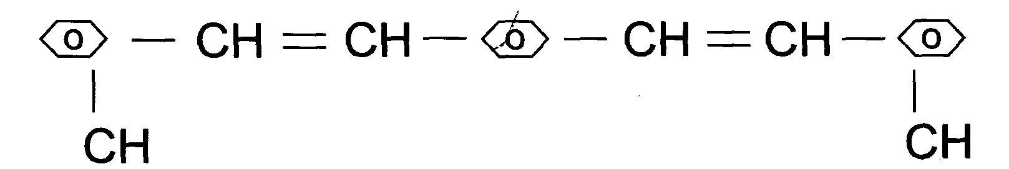
C.I.NO.: 199
Appearence: light yellow crystal
Melting Point: 225°C
lonization type; non-ion type
Solubility: Insoluble in water, soluble in DMF> choroform^ aceton and other organic solvent.
Uses: Have a good brightening effect to plastic ranule and
polyester fiber. Also could be used in the brightening and the adjustment of color and luster of printing ink, paint coating.
Packing: Iron drum lined with plastic bag, 25kg net weight each.

