FLUORESCENT BRIGHTENER HL
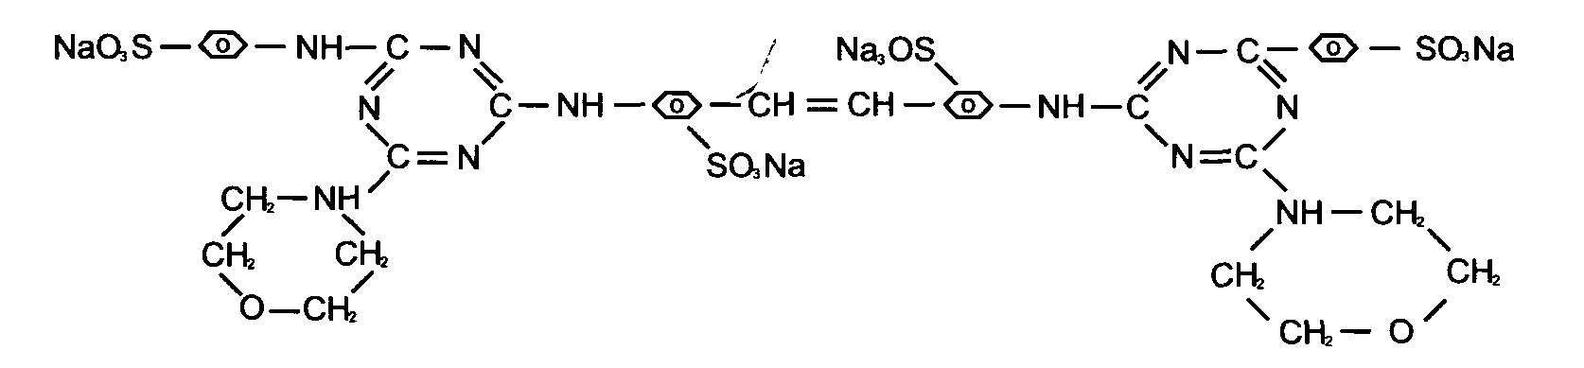
C.I.NO.: 210
Appearence: Light yellow powder
Moisture: 0.5%max
Dyeing degree: 0.4%min
Fluorescent whitening strength: 100% (Compare to the standard)
Finess (sieved residue through 80 mesh) : 10%max
Uses: Mainly used to whiten cotton fabrics? capron fabrics and pulp,
and also used to increase brightness of lightcolore fabrics.
Packing: Iron drum lined with plastic bag,net weight 25kg per drums.

