FLUORESCENT BRIGHTENER HD-2/EB
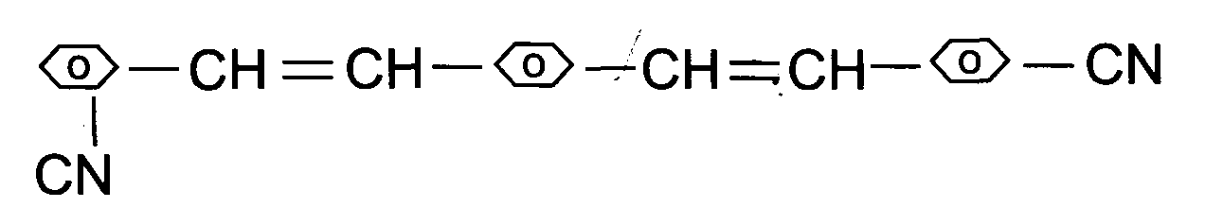
C.I.NO.: 199:1
Appearence: light yellow crystal
Melting Point: 180°C
lonization type: non-ion type
Solubility: Insoluble in water, soluble in DMF^ choroform^
aceton and other organic solvent.
Uses: Have a good brightening effect to plastic granule and polyester
fiber.Also could be used in the brightening and the adjustment of
color and luster of printing ink^ paint coating. 3
Packing: Iron drum lined with plastic bag,25kg net weight each.

