FLUORESCENT BRIGHTENER KCB

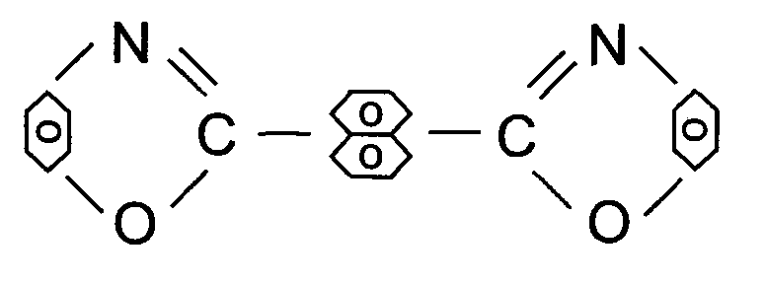
C.I.NO.: 367

Appearence: yellow green crystal
Shade: Similar to the standard sample
Solid content: 99.5%min
Melting Point: 210-212°C
Finess: Through 100 mesh.
Uses: Used to whiten synthetic cellulose fabric, plastic, plastic sheet,
press moulded material, polyester fabric, dyestuff and natural
paint coating.
Packing: Packed in bicorru gated paper case, lined with plastic bag, 10kg net weight each.

