FLUORESCENT BRIGHTENER KSN
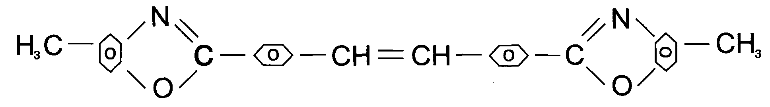
C.I.NO.: 368
Shade: Red
Appearance: Yellow crystal powder
Melting Point: 275 -280 °C
Assay: 99.5%min
Finess: Through 120 mesh
Uses: Used to whiten polyester ^ PA^ PAN fabric. Also can be used to
whiten plastic. Packing: 20kg paper drum lined with double plastic bag.

