FLUORESCENT BRIGHTENER MD

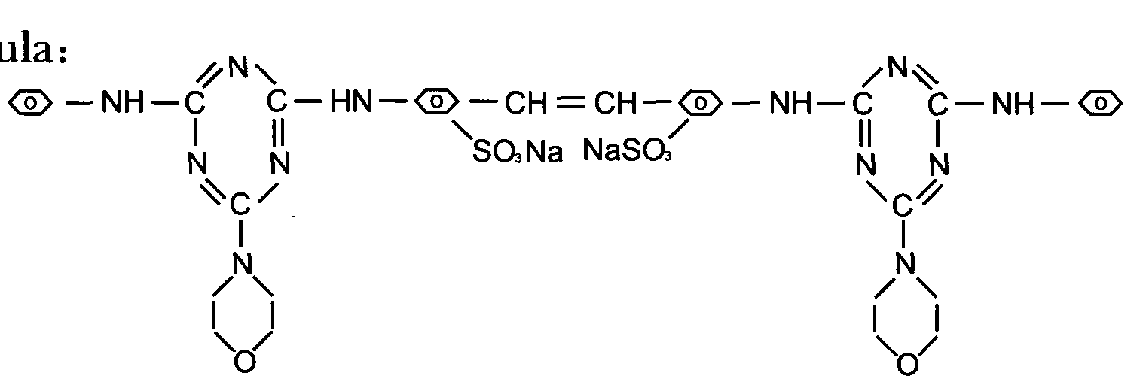
C.I.NO.: 260

Appearence: Light yellow powder
Moisture: 5%max
Shade: Similar to standard sample
Fluorescent whitening strength: 100% (Compare to the standard)
Finess (180um) : 10%max
Uses: Used to whiten and brighten synthetic washing agen^ paper^ and cellulose fabric.When used in washing powder, soap, the washed fibre will be brightened and whitened and the detersive efficiency will be improved.
Packing: 25kg paper drums

