FLUORESCENT BRIGHTENER OB-1
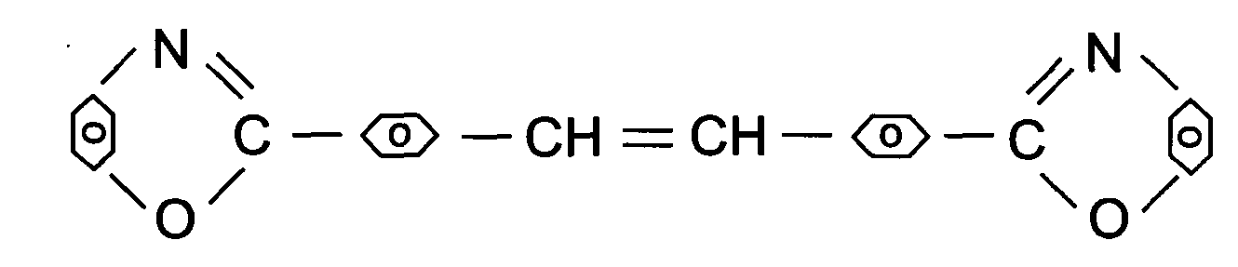
C.I.NO.: 398-1
Appearence: yellow crystal powder
Solid content: 99.5%MIN
Melting Point: 351-353°C
Finess: Through 120 mesh.
Uses: Used to whiten original polyester liquid. Especial for increasing
whiteness of dacron fibre cottony fabric blending, and plastic products.
Packing: Packed in bicorrugated paper case,lined with plastic bag, 10kg net weight each.

