FLUORESCENT BRIGHTENER OB
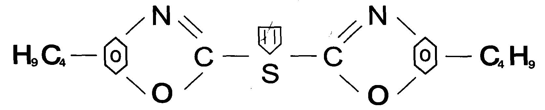
C.I.NO.: 184
Appearence: yellow green crystal powder
Solid content: 99.5%min
Melting point: 196-203°C
Shade: Similar to the standard sample
Finess: Through 100 mesh
Uses: Used to whiten thermoplastics materials PE^ PP^ PS^ ABS^
SAN^ SB^ CA> PA^ PMMA^ decron fibrk^ oil varnish^ paints
and paper.
Packing: Packed in bicorrugated paper case, lined with plastic bag, 10kg net weight each.

