FLUORESCENT BRIGHTENER PB/EBF
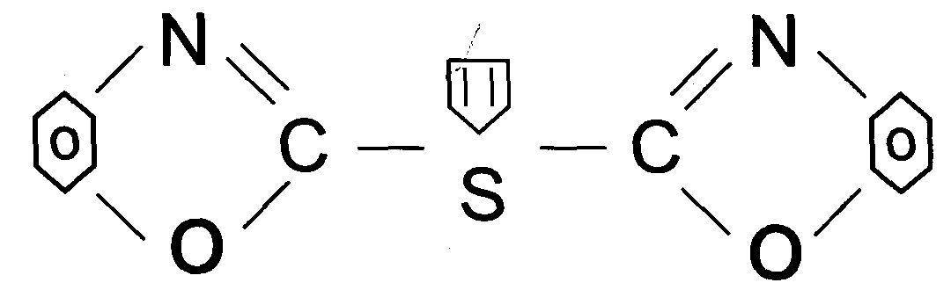
C.I.NO.: 185
Appearence: light yellow crystal powder
Shade: Similar to the standard sample
Solid content: 99.5%min
Melting point: 216-220C
Finess: Through 100 mesh
Uses: Used to whiten varitious of polyene plastics, engineering ABS
plastics.
Packing: Packed in bicorrugated paper case, lined with plastic bag, 10kg net weight sach.

