FLUORESCENT BRIGHTENER PBL
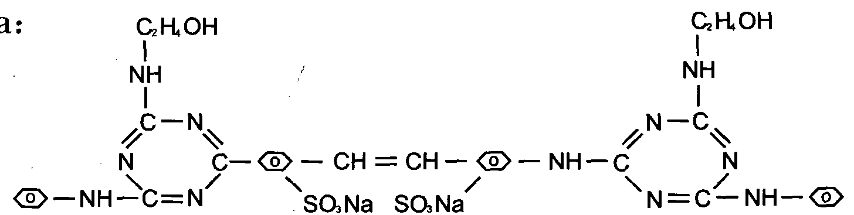
C.I.NO.: 216
Appearence: Light yellow or white powder
Insoluble in water: 0.5%max
Moisture: 5%max
Shade: similar to standard
Dying degree: 0.5%min
Fluorescent whitening strength: 100% (Compare to the standard)
Finess (sieved residue through 180 mesh) : 10%max
Uses: Mainly used to whiten white fibre, paper and lightn colorded fibre.
Also used to whiten material in discharging printing. Packing: Iron drum lined with plastic bag,net weight 25kg per drums

