FLUORESCENT BRIGHTENER SFW-Y
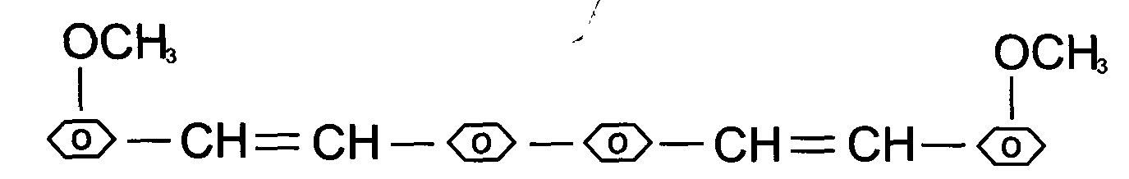
C.I.NO.: 127
Appearence: Light yellow crystal powder
Melting: 216-222°C
Purity: 99.0%min
Weightlessness of dry: 0.5%max
Ash content: 0.1%max
Uses: Widely used in the process of plastic ^ synthetic washing powder ^
printing and dyeings laundering and dying and artificial fiber
etc.
Packing: Iron durm lined with plastic bag, net weight 25kg per drums

