FLUORESCENT BRIGHTENER SFW-X
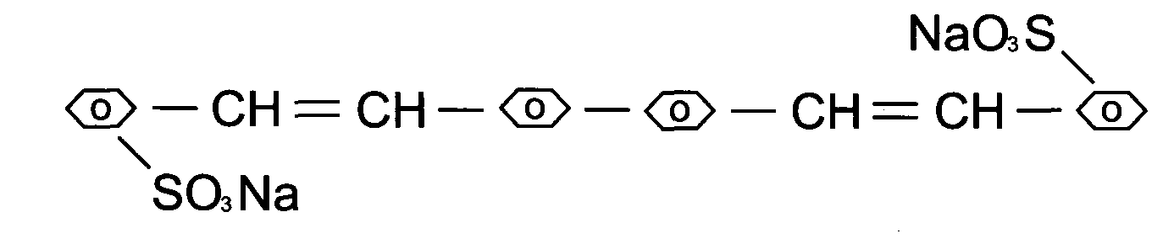
C.I.NO.: 351
Appearence: Free-flowing brilliant yellow granule
Shade: Simiar with the standard sample
Insoluble in water: 0.5%max Fluorescent whitening strength: 100%(Compare to the standard)
Uses : Mainly used to brighten synthetic washing agent, perfumed soap
and soap. Also could be used to brighten cotton gunny^ silk^
polyamide fibre ^ wooland paper etc. Packing: Iron drum lined with plastic bag, net weight 25kg per drums.

