FLUORESCENT BRIGHTENER VBL
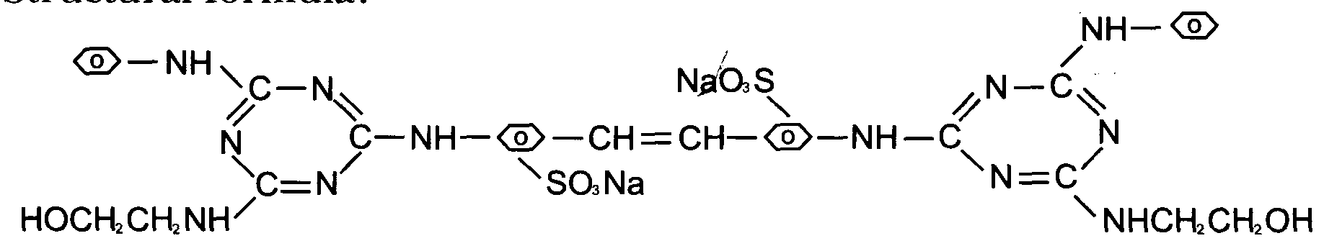
C.I.NO.: 85
Appearence: Light yellow powder
Insoluble in water: 0.5%max
Moisture: 5%max
Shade: similar to standard
Dying degree: 0.4%min
Fluorescent whitening strength: 100% (Compare to the standard)
Finess (sieved residue through 80 mesh ) : 10%max
Uses: Mainly used to whiten cotton fabrics ^ cap ron fabrics and pulp,
and also used to increase brightness of lighcolored fabrics.
Packing: Iron durm lined with plastic bag, net weight 25kg per drums

