FLUORESCENT BRIGHTENER VBU
Structural formula:
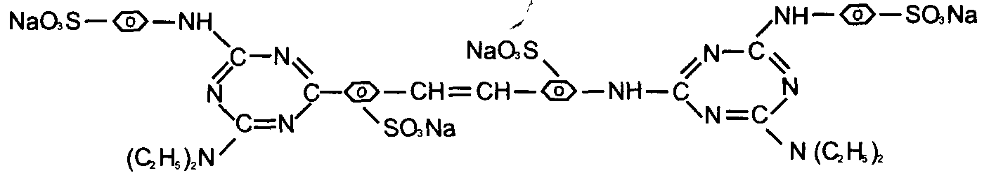
C.I.NO.: 87
Appearence: Light yellow powder
Insoluble in water: 0.5%max
Moisture: 5%max
Shade: similar to standard
Dying degree: 0.5%min
Fluorescent whitening strength: 100% (Compare to the standard)
Finess (sieved residue through 80 mesh ) : 10%max
Uses: Mainly used to whiten cotton fabrics ^ capron fabrics and pulp,
and also used to increase brightness of lighcolored fabrics.
Packing: Iron drum lined with plastic bag» net weight 25kg per drums

